GOMART (Retail Management System)
____________________________________



by
Student Name:
MARYAM JAMIL
2025-(S)CS-135
AYMAN SAUD
2025-(S)-CS-150
Subject Instructor:
Ms. Rimsha Afzal
_______________________________________
Department Name
University of Engineering and Technology, Lahore
APPROVED BY:

[Class Instructor: Ms. Rimsha Afzal

[Subject Advisor: Prof. Dr. Awais Hassan

[Chairman of the Department]

DEPARTMENT NAME
UNIVERSITY OF ENGINEERING & TECHNOLOGY, LAHORE

ABSTRACT
GoMart is a C# Windows Forms–based Retail Management System developed using Object-Oriented Programming principles and a layered architecture. The system manages categories, products, sellers, admins, billing, and sales using SQL Server for persistent storage. The project demonstrates encapsulation, inheritance, polymorphism, and separation of concerns through UI, Business Logic (BL), and Data Layer (DL). The system aims to automate retail operations, reduce manual work, and ensure data accuracy and consistency.

1. INTRODUCTION
GoMart is a desktop-based retail management application developed in C# using Windows Forms and SQL Server. The project is designed to handle retail operations such as managing categories, products, admins, sellers, and billing. By applying OOP concepts and layered architecture, the system becomes modular, maintainable, and scalable. The application separates user interface, business rules, and database access, which reflects real-world enterprise software development.

1.1: Project Objectives
Centralized Management: Allow admins to manage sellers, products, categories, and brands from a single system.
Efficient Product Management: Enable sellers to add, update, or remove their products easily.
Order Tracking: Admins can monitor orders placed by sellers.
Accurate Records: Ensure consistent and up-to-date inventory and sales information.
Secure Access: Restrict system access to authorized admins and sellers.
Reporting: Generate reports for sales, inventory, and seller activity.
Scalability: Support growth in product numbers, sellers, and orders.

1.2: Functional Requirements
Admin Features:
Login securely.
Add, update, or remove sellers.
Manage product categories and brands.
View, update, or delete any product.
Track all seller activity and orders.
Generate reports (inventory, sales, seller performance).
Seller Features:
Login securely.
Add new products with details (name, category, brand, price, stock).
Update or remove their own products.
View orders for their products.
Generate sales reports for their products

1.3: Non-Functional Requirements
Performance: Fast response for all CRUD operations (add, update, delete, view).
Reliability: Maintain accurate data and uptime of at least 99%.
Security: Encrypted passwords, role-based access, and secure database connections.
Usability: Simple interface for admins and sellers; minimal learning curve.
Maintainability: Modular, well-documented code for easy updates.
Compatibility: Works on Windows systems (since it’s likely C# WinForms).

1.4: Motivational Background
Many small and medium-sized businesses face challenges in managing their inventory, products, and orders efficiently. Manual record-keeping and decentralized management often lead to errors, delays, and inefficiency.
GoMart was developed to address these issues by providing a centralized management system where:
Admins can manage sellers, categories, and products.
Sellers can add and update their products efficiently.
The system maintains accurate records of inventory, sales, and orders.
The main motivation is to streamline business operations, improve productivity, and reduce human error in product and order management.

2. Literature Review

2.1 Overview
Retail management systems (RMS) have evolved from manual billing, stock-taking, and record maintenance to advanced digital solutions that integrate inventory management, order tracking, and reporting. Early systems were mainly desktop-based with limited automation and reporting capabilities, while modern solutions emphasize efficiency, data accuracy, and scalability.
This section provides a comparative analysis of some well-known retail management and inventory systems, such as Tally ERP, Zoho Inventory, Odoo, Vend, and QuickBooks Commerce, highlighting their limitations and how the proposed GoMart system addresses these gaps with a lightweight, desktop-based, C# .NET–based solution.
S. No. | System Name | Technology / Platform | Key Features | Limitations | Comparison with Proposed System
1 | Tally ERP | Windows-based, Proprietary | Accounting, inventory management, reporting | High license cost; complex setup; primarily accounting-focused | GoMart is free, focused on inventory & product management for admins & sellers; simpler setup
2 | Zoho Inventory | Cloud-based, Web (Java, MySQL) | Inventory tracking, multi-channel sales, reporting | Requires internet; subscription-based; limited offline functionality | GoMart is desktop-based, works offline, and allows local inventory management without internet
3 | Odoo | Open-source, Web (Python, PostgreSQL) | Inventory, sales, CRM, multi-user support | Complex configuration; web-based; resource-intensive | GoMart offers a simpler, lightweight desktop solution for smaller businesses or single-location stores
4 | Vend | Cloud-based, Web (JavaScript) | Point-of-sale, inventory tracking, reporting | Requires subscription; internet dependency; limited local customization | GoMart runs locally, fully customizable, does not rely on internet connectivity
5 | QuickBooks Commerce | Cloud-based, Web (JavaScript, SQL) | Inventory, sales, order tracking, reporting | Subscription cost; mainly accounting-focused; limited offline use | GoMart provides inventory and product management only, fully offline, and free for use in small/medium setups

3.Architecture Diagram:
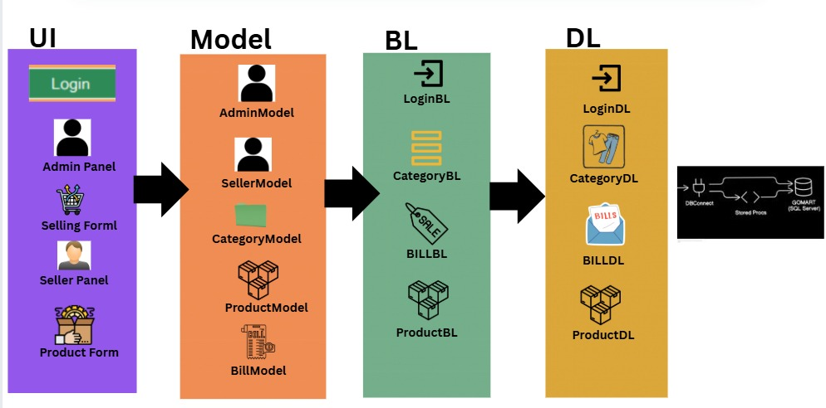

3.1 System Overview
GoMart allows admins to manage categories, products, sellers, and view reports. Sellers can log in, sell products, and generate bills. All data is stored in a SQL Server database.

Flow Diagram:
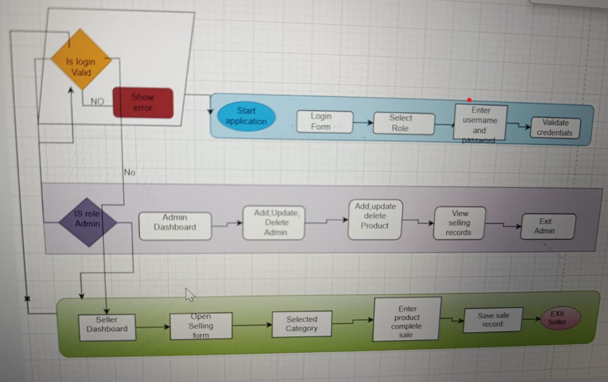

User Flow:
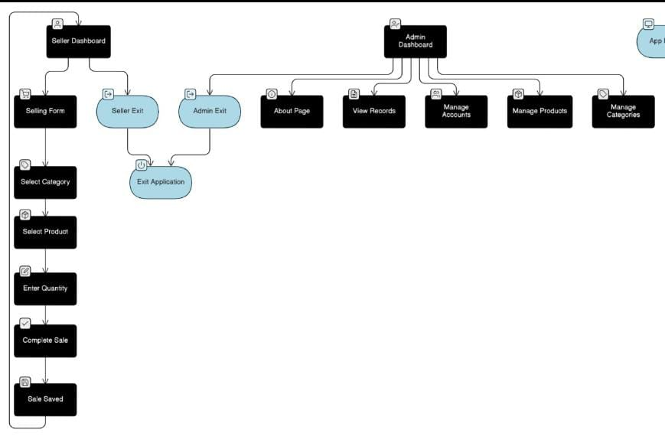

Programmer Flow:
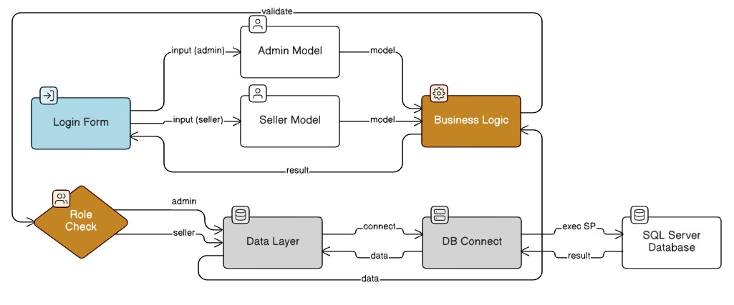

7. SYSTEM DIAGRAMS

7.1 Class Diagram
Includes classes such as User, Admin, Seller, Category, Product, Bill, BillDetails with attributes and methods.
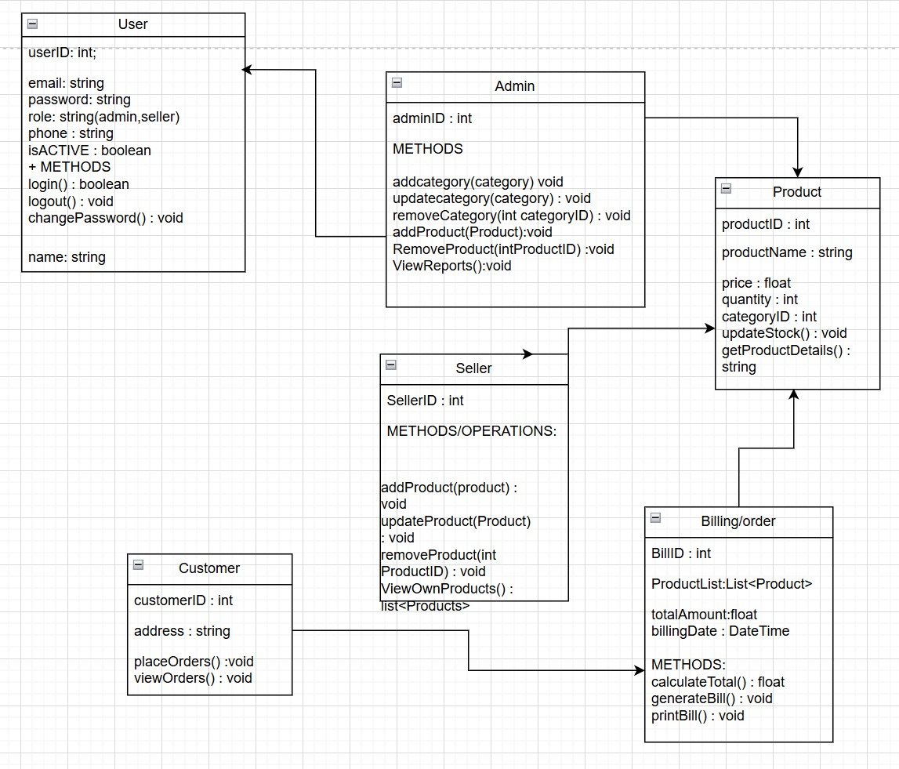

7.2 Entity Relationship Diagram (ERD)
One Category → Many Products
One Seller → Many Bills
One Bill → Many BillDetails
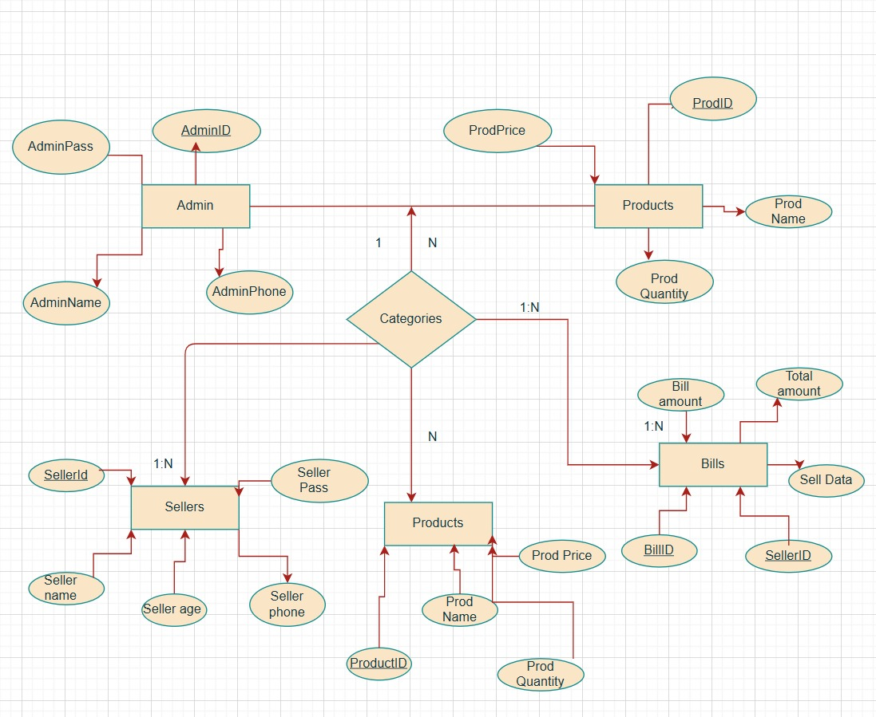

7.3 Use Case Diagram
Actors:
Admin
Seller
Use Cases:
Login
Manage Categories
Manage Products
Manage Sellers
Generate Bill
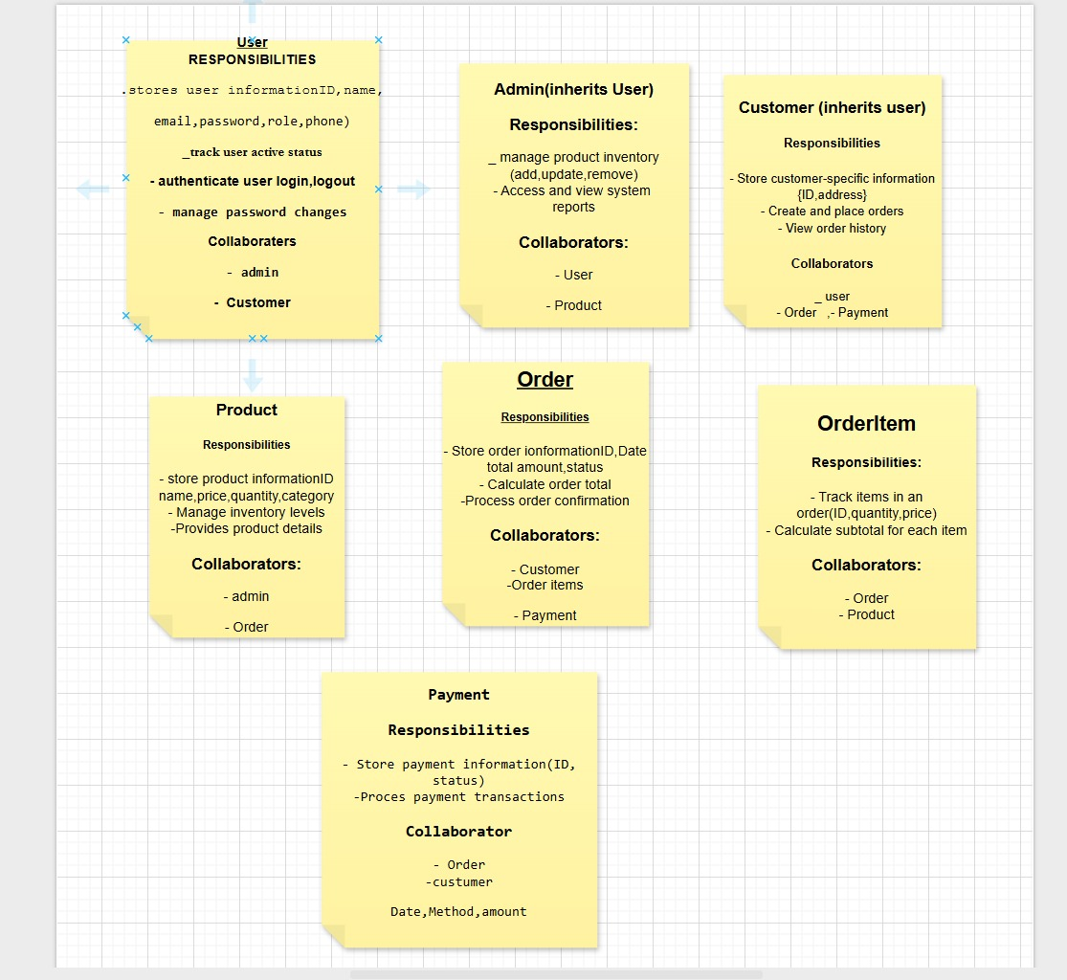

7.4:Flow Diagram
Start → Login → Role Selection → Perform Operations → Logout

7.5 Class Descriptions
Class | Purpose
Admin | Manage system data
Seller | Perform selling operations
Category | Store category data
Product | Store product data
Bill | Store billing info
BillDetails | Store sold items

8. IMPLEMENTATION

8.1 Encapsulation
Private fields with public properties are used to protect data.

8.2 Constructors
Default and parameterized constructors initialize objects.

8.3 Lists & Collections
DataTables and Lists are used to store records temporarily.

8.4 Inheritance
User is the parent class; Admin and Seller inherit from it.

8.5 Static Polymorphism
Method overloading is used in BL classes.

8.6 Dynamic Polymorphism
Virtual and override methods are used for role-based behavior.

8.7 Method Hiding
new keyword is used where required.

8.8 Database Connectivity
ADO.NET with SqlConnection, SqlCommand, and SqlDataAdapter is used.

9. DATABASE DESIGN

9.1 ERD Mapping
Each class is mapped to a database table.

9.2 Create Table Scripts
CREATE TABLE Category(
CatID INT PRIMARY KEY IDENTITY,
CategoryName NVARCHAR(100)
);

10. TESTING

10.1 Test Cases
Test Case | Description | Result
TC-01 | Admin Login | Pass
TC-02 | Add Category | Pass
TC-03 | Add Product | Pass
TC-04 | Generate Bill | Pass

10.2 Output Screenshots
Screenshots of login, category, product, and selling forms.
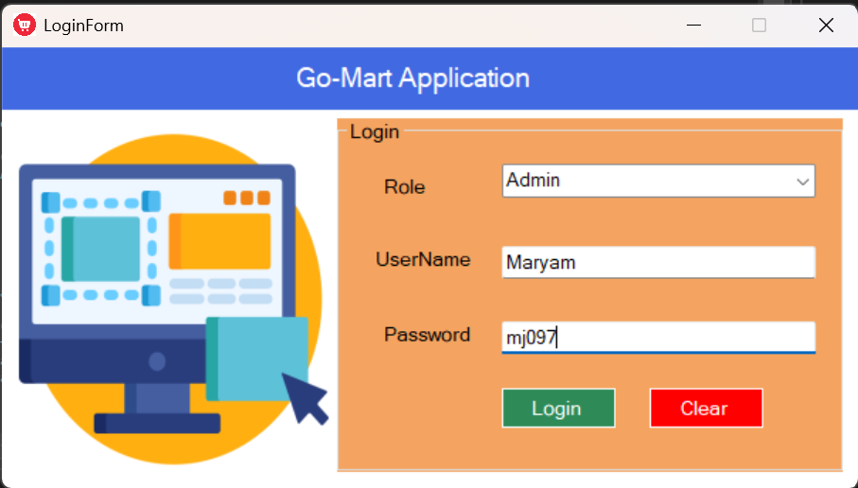

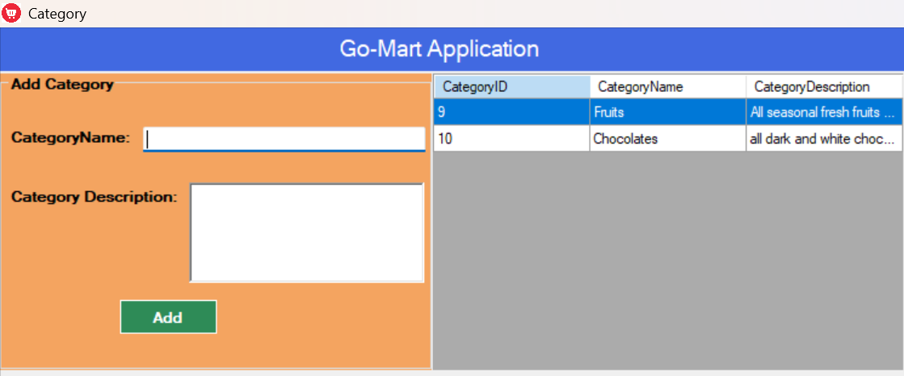
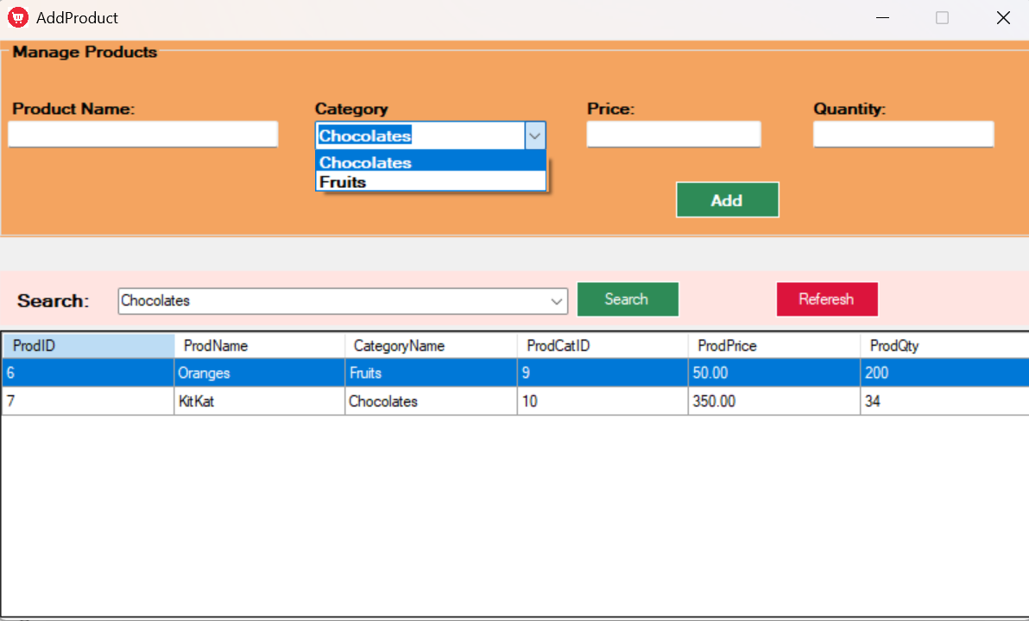
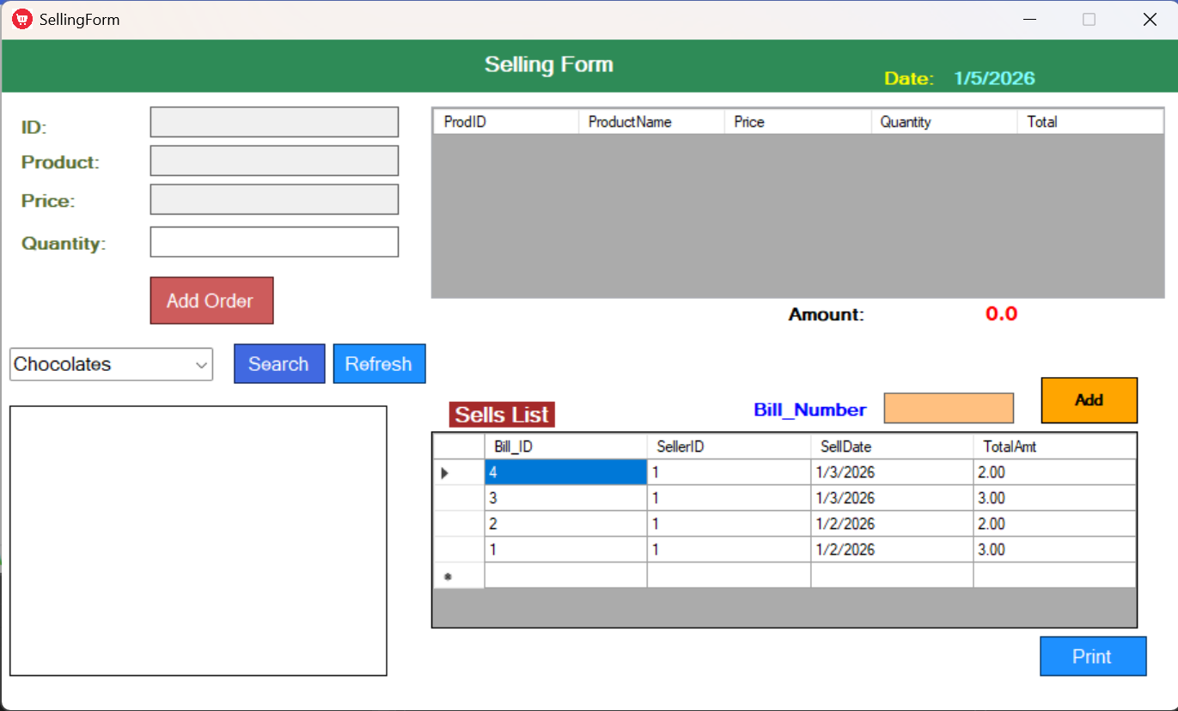
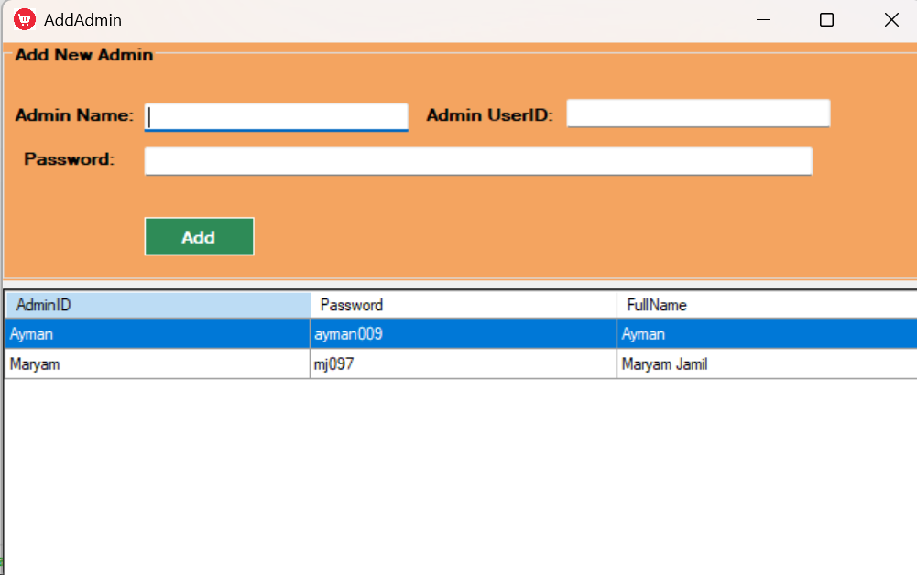

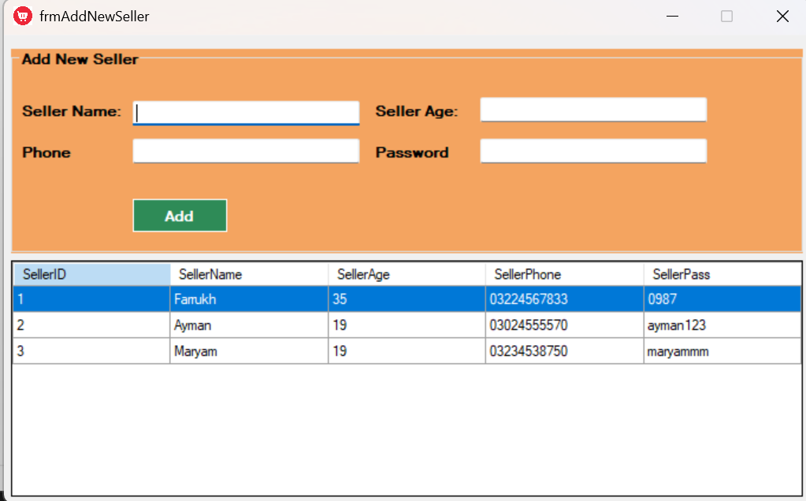
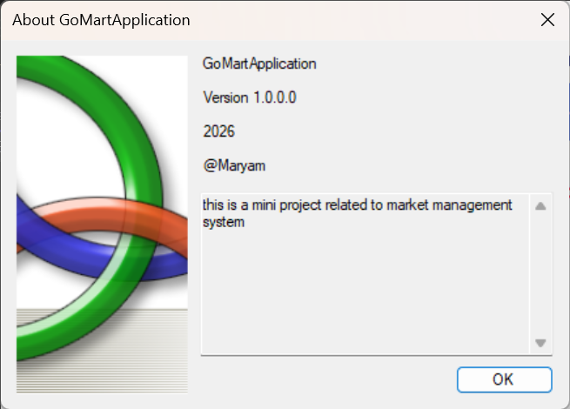

11. CONCLUSION
The GoMart application successfully demonstrates Object-Oriented Programming concepts and layered architecture. The system efficiently manages retail operations and ensures data consistency through database integration. The project fulfills all objectives and provides a strong foundation for future enhancements.

12. REFERENCES
Microsoft Docs – C# and ADO.NET
Object-Oriented Programming in C#
Lecture Notes – Ms. Rimsha Afzal

